House for Rent

Farmington Hills

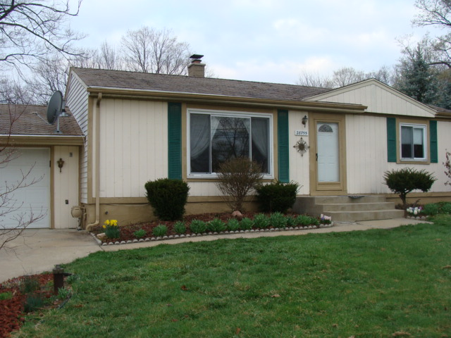

Three Bedrooms. Nice house with large yard in quiet neighborhood. Complete with two car garage and shed. Central Air, Stove, Refrigerator, Dishwasher. Washer, Dryer. Close to Expressway. Rent $1175/month. Farmington Hills Schools, walk to Highmeadow elementary. Call 248-669-1245

3 Bedroom Farmington Hills  Call 248-669-1245 | 3 Bedroom Farmington Hills  Call 248-669-1245 | 3 Bedroom Farmington Hills  Call 248-669-1245 | 3 Bedroom Farmington Hills  Call 248-669-1245 | 3 Bedroom Farmington Hills  Call 248-669-1245 | 3 Bedroom Farmington Hills  Call 248-669-1245 | 3 Bedroom Farmington Hills  Call 248-669-1245 | 3 Bedroom Farmington Hills  Call 248-669-1245 | 3 Bedroom Farmington Hills  Call 248-669-1245 | 3 Bedroom Farmington Hills  Call 248-669-1245 | 3 Bedroom Farmington Hills  Call 248-669-1245 | 3 Bedroom Farmington Hills  Call 248-669-1245

