House for Rent

Walled Lake

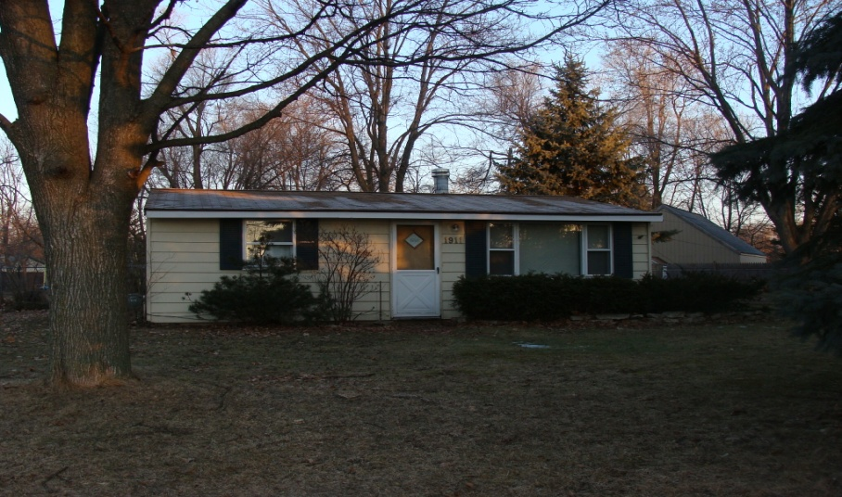

Two Bedrooms. Nice house with large yard in quiet neighborhood. Complete with deck and shed. Stove, Refrigerator, Dishwasher. Close to M5. Rent $750/month. Walled Lake Schools, close to Guest Elementary. Call 248-669-1245

2 Bedroom Walled Lake  Call 248-669-1245 | 2 Bedroom Walled Lake  Call 248-669-1245 | 2 Bedroom Walled Lake  Call 248-669-1245 | 2 Bedroom Walled Lake  Call 248-669-1245 | 2 Bedroom Walled Lake  Call 248-669-1245 | 2 Bedroom Walled Lake  Call 248-669-1245 | 2 Bedroom Walled Lake  Call 248-669-1245 | 2 Bedroom Walled Lake  Call 248-669-1245 | 2 Bedroom Walled Lake  Call 248-669-1245 | 2 Bedroom Walled Lake  Call 248-669-1245 | 2 Bedroom Walled Lake  Call 248-669-1245 | 2 Bedroom Walled Lake  Call 248-669-1245

